## **CARROT QUEST : THE ROOT OF EVIL**

By Dark Root (Joy Shideler, Brenton Figures-Mormon)

2023

**Platform: PC ● Target Audience: Teens and up ● ESRB Rating: T ● Number of Players: 1**

*COMING SPRING OF 2024…*



*Use a Logo and art, even if basic.*

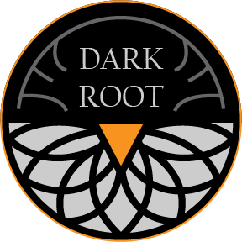

1. Title Page

2. Game Outline

3. Character

4. Gameplay

5. Game World

6. Game Experience

7. Gameplay Mechanics

8. Enemies

9. Multiplayer / Bonus Materials

10. Monetization

## GAME OUTLINE

*Shoot monsters and save Bunnyville!*

A terrible curse has swept over Bunnyville, causing their citizens to mutate into roving, carrot-hungry beasts. You, the Vagabond bunny, must go on a quest to defeat these abominations and put a stop to the source!

Starting off with a sword and revolver, the player must first make their way through the fields surrounding Bunnyville as they fight monsters and talk to various characters. Soon however, they will roam the twisted forest paths and the desert plains as they seek the source of the curse. Finally, the player will venture beneath Bunnyville, into the ancient ruins of the previous kingdom… what dark secrets will they find there?

*Game Flow Outline*

Flow of the game

Environments

Challenges

Progression

Victory

Gameplay to story

## CHARACTER

**The Vagabond**

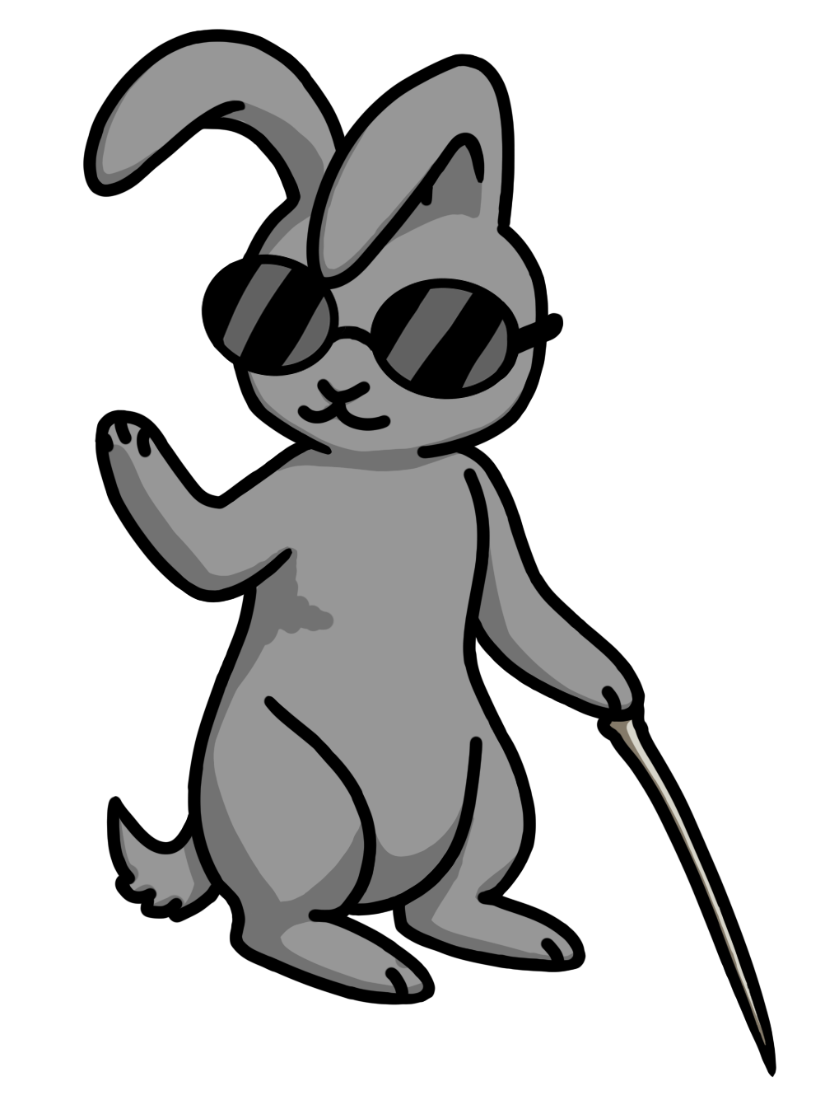

**Hyacinth**

**Oakly**

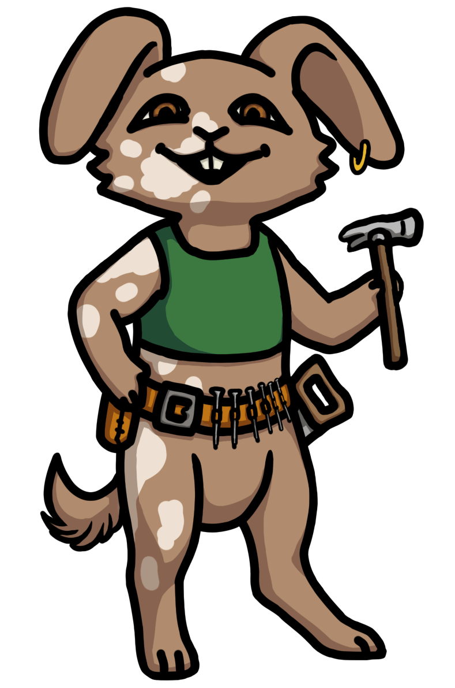

**Dewdrop**

Character(s)

Details pertinent to game

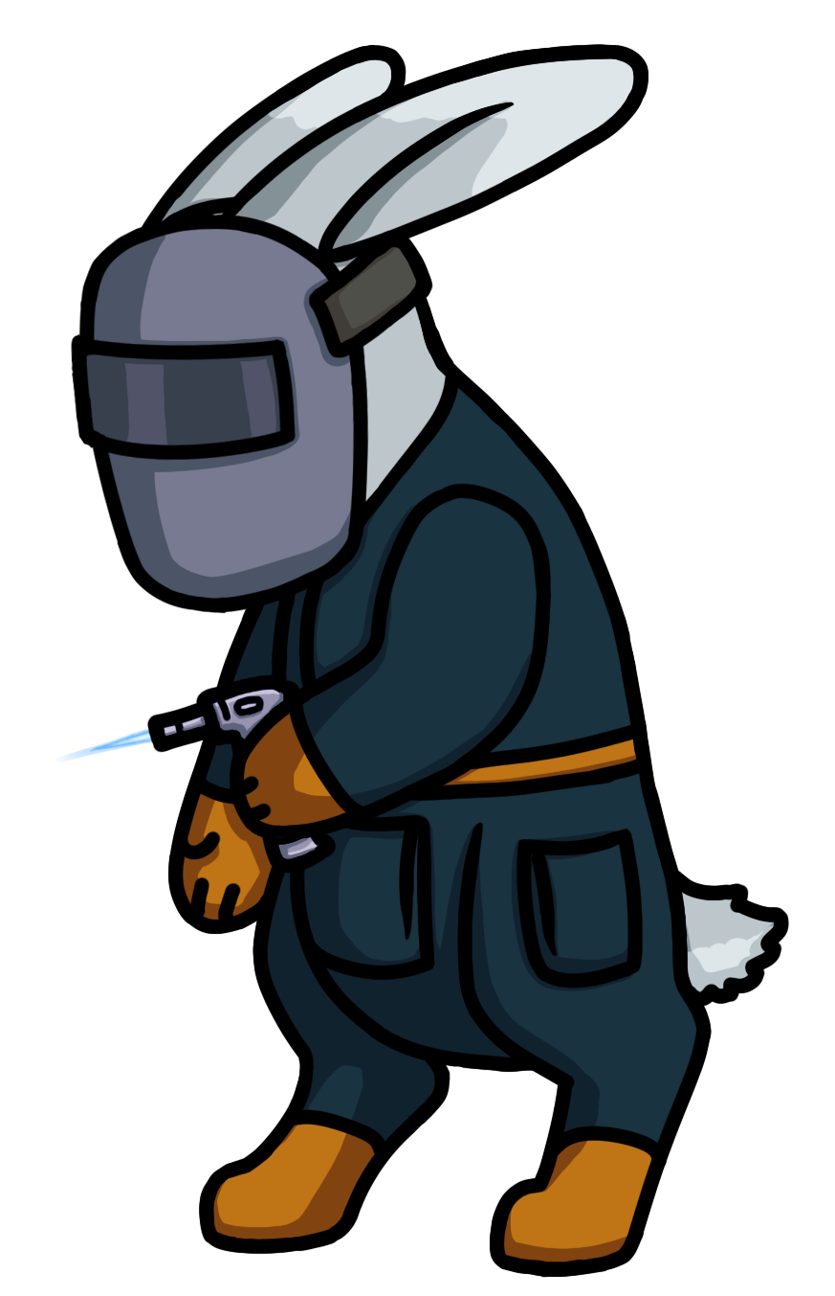Concept Art

Backstory

Special moves /abilities

Character Controls

## GAMEPLAY

Gameplay

Genre

Sequence of play

Big set pieces

Features

USPs!

Diagrams

Platform specific stuff?

## GAME WORLD

Game World

Environments

Images/descriptions

Mood/music

Flow diagram

Maps, etc.

## GAME EXPERIENCE

Gestalt

Talks about the mood of the game

Describes the UX and possibly UI

Music

Brings all design elements together

## GAMEPLAY MECHANICS

Gameplay Mechanics

Mechanics

Hazards

Power-ups

Collectibles

Economy

Etc.

## ENEMIES

Enemies

NPCs

AI

Bosses

## MULTIPLAYER / BONUS MATERIALS

Multiplayer and Bonus

MP/Co-op/Solo?

User Generated content

Achievements

Unlockables

DLC?

## MONETIZATION

How it will make money

One time payment?

DLC?

Free-to-play?

Combination?

How do purchases affect game?